Setup and Install
To begin installation, run the Setup.exe
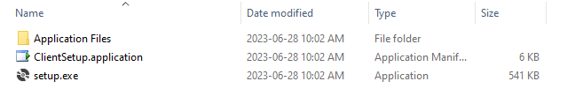
Once installed, the following setup form is displayed:
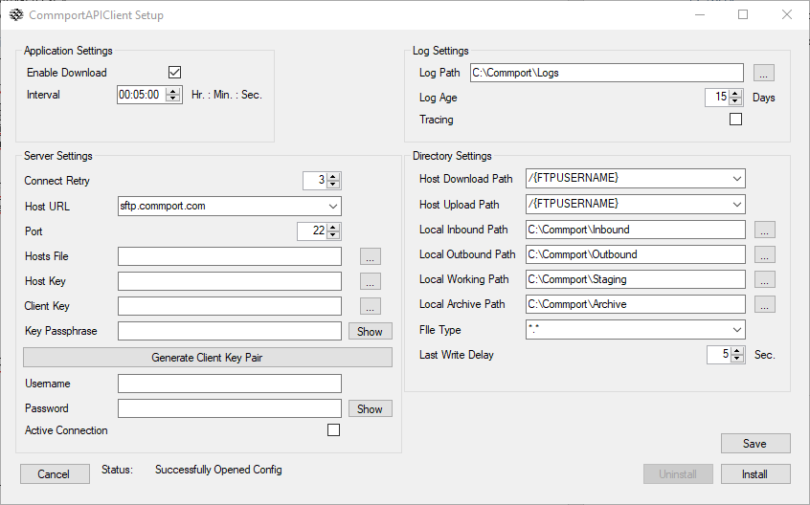

Edit the following settings as required for the user, names in bold indicate required fields to be filled out by the user:
- Enable Download: Check to enable downloading, uncheck to disable downloading.
- Interval: Upload/Download period.
- Log Path: Logging root path.
- Log Age: Log retention time in days.
- Tracing: Check to enable tracing for verbose messaging, uncheck for successful, failures and errors only.
- Connect Retry: Connection attempts before failing.
- Host URL: URL for connection
  - Sftp.Commport.com
- Host File: Known host public key list file
- Host Key: Server public key
- Client Key: Client private key; described in further detail below.
- Key Passphrase: Client private key passphrase; described in further detail below.
- Username: Server Username
- Password: Server Password
- Active Connection: Check to enable active connection mode, uncheck for passive connection mode.
  - When the connection-mode is active, the server will initiate connections to the SFTP client, meaning that the SFTP client must open a socket and wait for the server to connect to it. This often causes problems if the SFTP client is behind a firewall.
  - When the connection-mode is passive, the SFTP client will initiate connections to the server, meaning that the SFTP client will connect to a particular socket on the server. This is generally used if the SFTP client is behind a firewall.
- Host Download Path:
  - /
  - /FromCommport
  - User defined
- Host Upload Path:
  - /ToCommport
  - /MailIn
  - User defined
- Local Inbound Path: Local path for downloading
- Local Outbound Path: Local path for uploading
- Local Working Path: Local working path
- Local Archive Path: Local archive path
- File Type: File types for uploading/downloading
  - EDI = *.edi
  - Text = *.txt
  - All = *.*
- Last Write Delay: File last write delay before uploading/downloading

If a client key pair is required, press the Generate Client Key Pair button to begin key creation by PuTTY Key Generator:
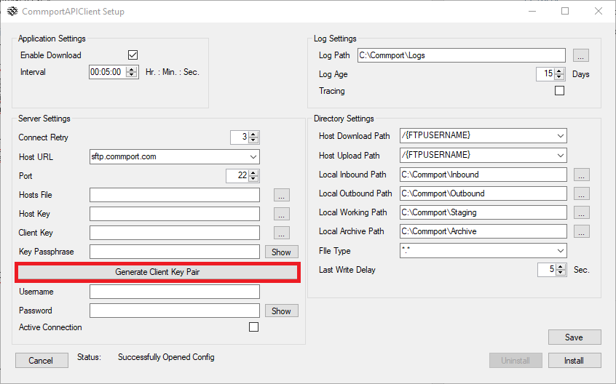
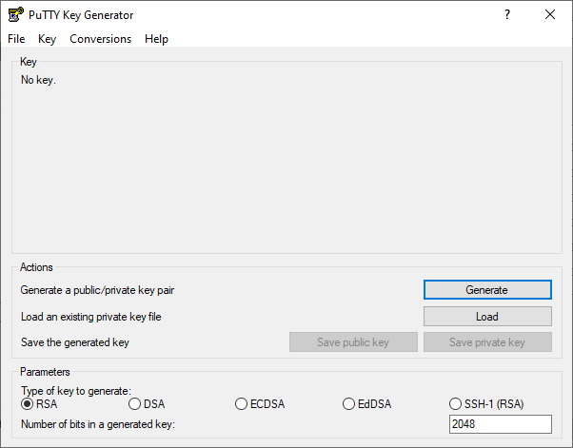
Select the Generate button to begin Key creation and follow on-screen instructions.
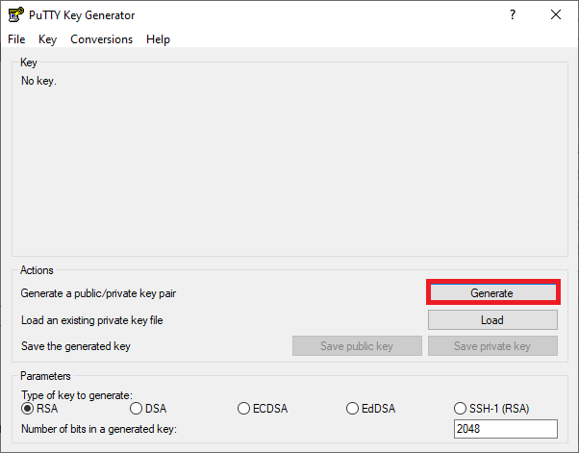
NOTE: Moving mouse over the empty screen is required by the PuTTY tool when generating the key.
Once the key is generated by PuTTY Key Generator, assign the private key a passphrase and save the private/public key combination. The public key is to be sent to Commport for setup and configuration of the user account on the SFTP server:
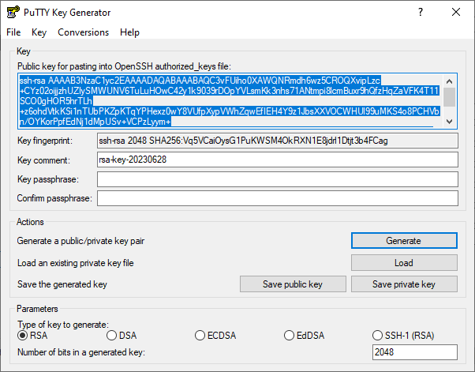

With a private key available and associated public key sent to Commport for configuration, ensure the Client Key, Key Passphrase, Username, and Password are set for the connecting user account.
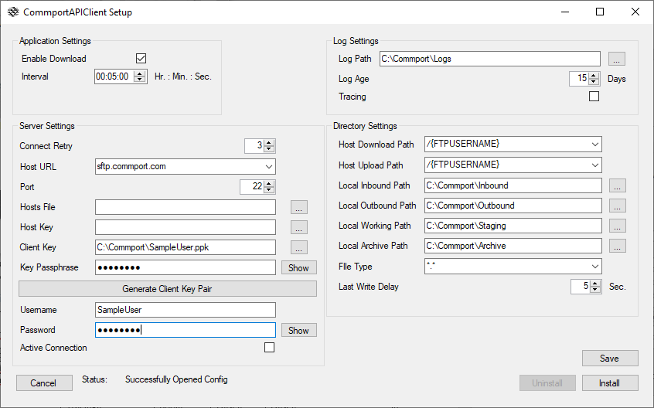
Press the Install button once the required user configuration information is set:
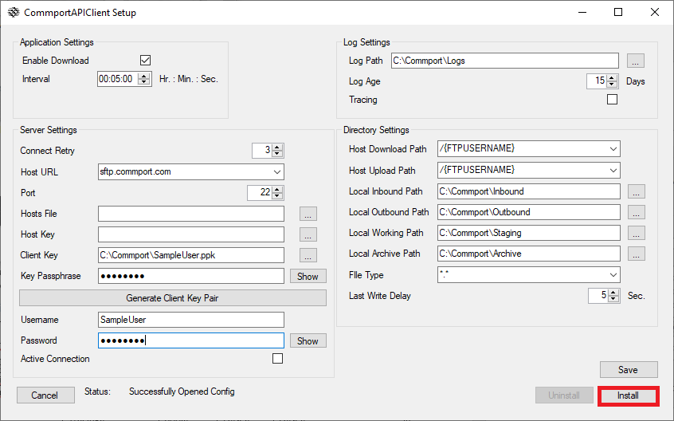
Once the service is successfully configured and installed the user is prompted to leave or close the screen:
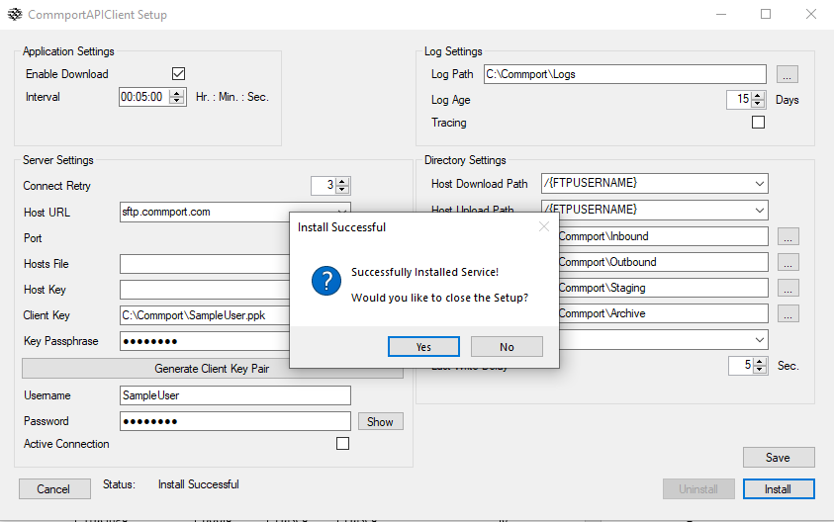To begin uninstallation of the service, press the Uninstall button:
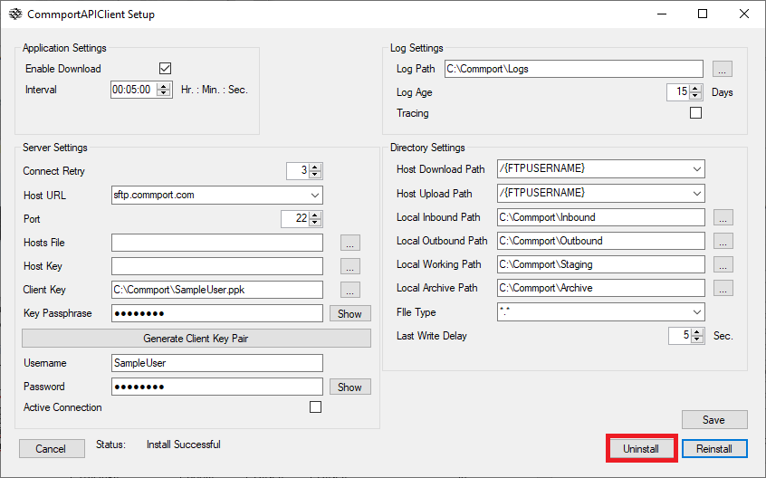
Once uninstalled, the form will appear as follows: 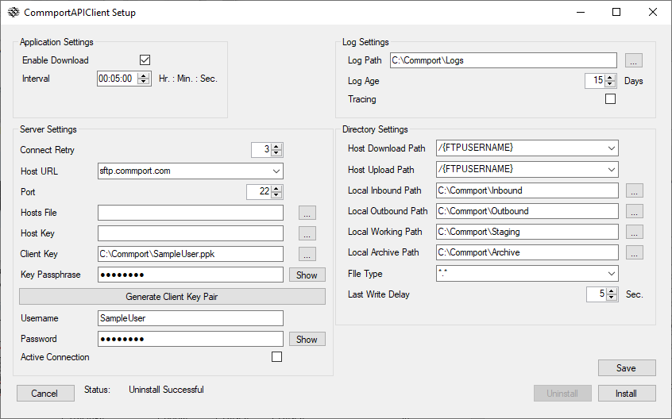
Press the Save button to update the configuration:
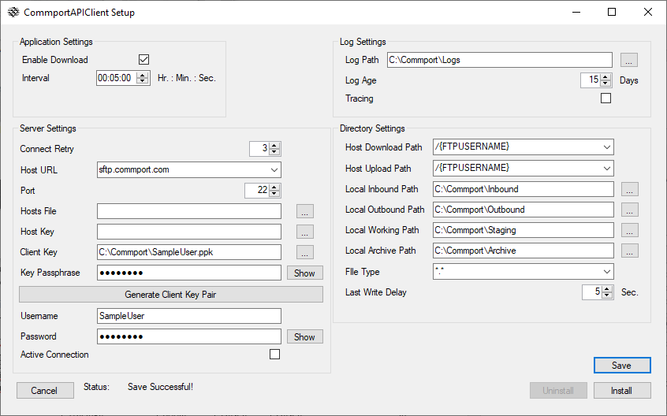

Usage

Start
Start via Windows Service viewer

Stop
Stoppable via Windows Service viewer

Upload
Add file to the “Local Outbound Path” folder specified during setup, DirSettings.OutboundDir.
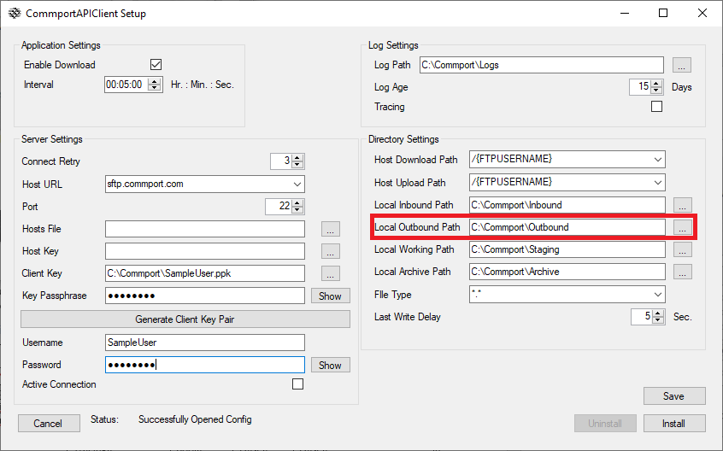

Download
If “Enable Download” is checked, file automatically downloads when detected in “Host Download Path” folder to the “Local Inbound Path” specified during setup, DirSettings.InboundDir.
